**Ocean Post Trade Autosys KT**

URLs : <https://globalconsumer.collaborationtools.consumer.citigroup.net/sites/Autosys/autosys/R11.3.6/Shared%20Documents/PubDocs/NAM%20Workload%20Control%20Center%20Pages.htm>.

Click WCC8

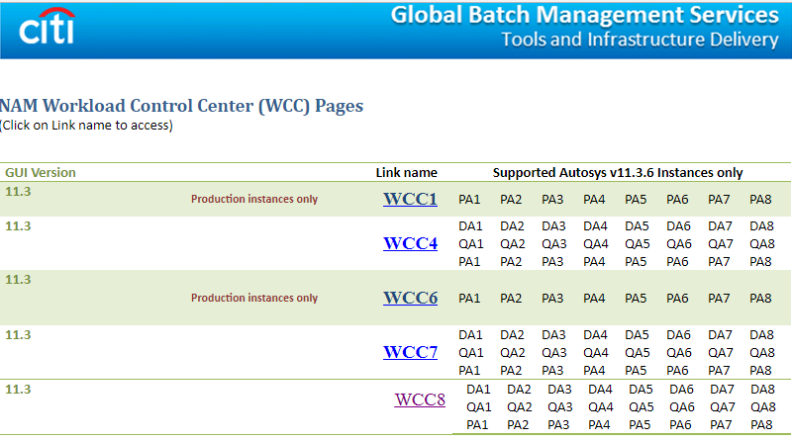

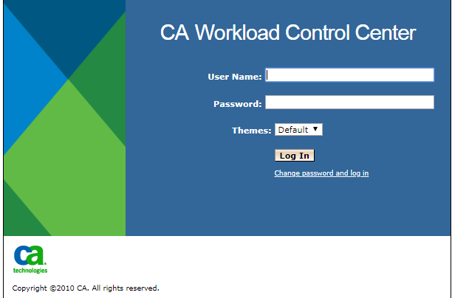

User Name : SOEID   
Password : SSO password

Incoming feed path : /global/ocean/data/incoming/ocean_2_0/<SYSTEM_NAME>

odac path : /global/ocean/data/ocean/data/glob/<system>/odac/<business_date>/data

FTP files (bulk files)

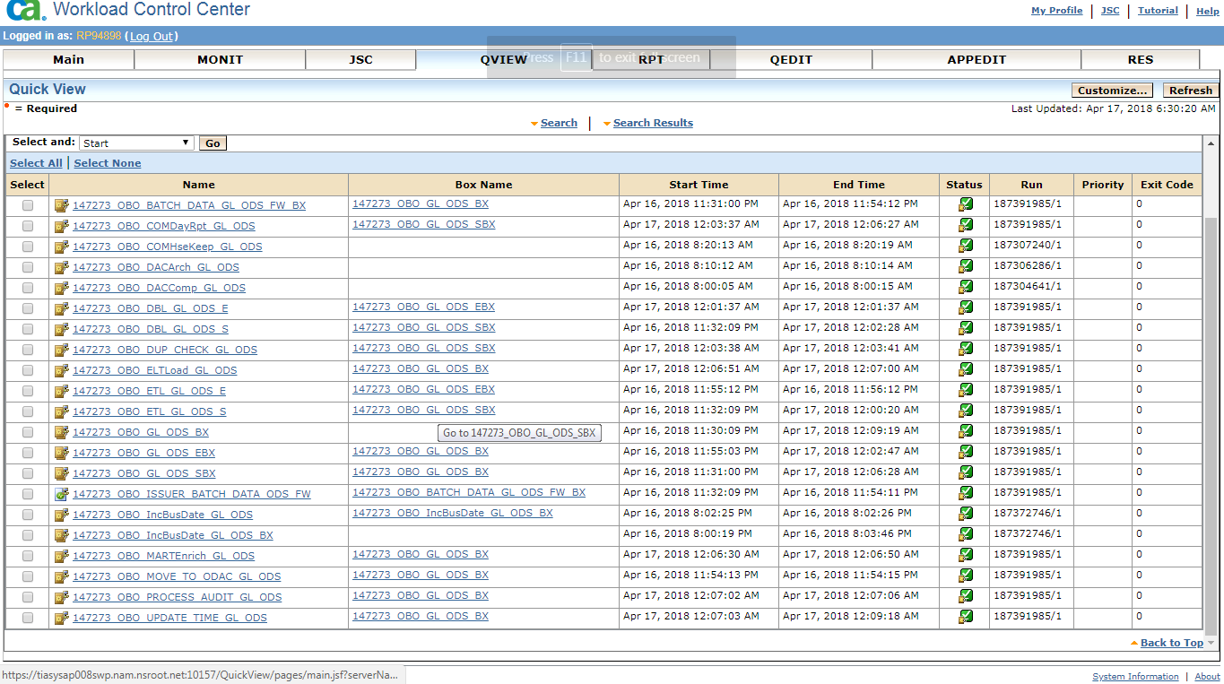

Fix file format (messages)

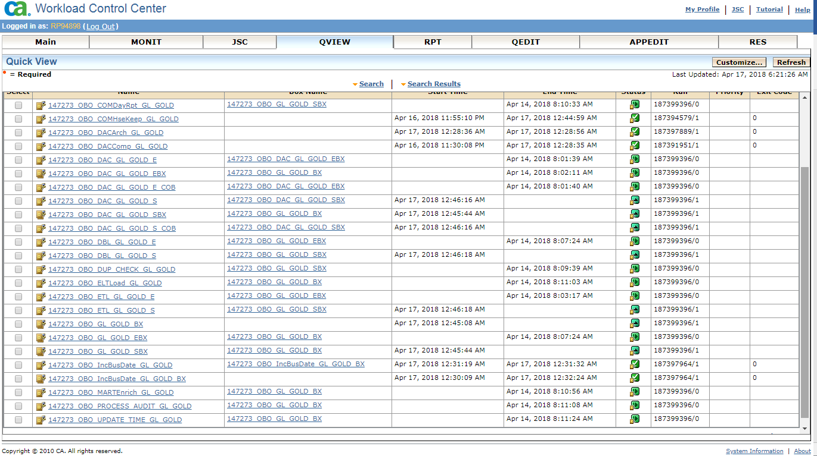

Sequential order

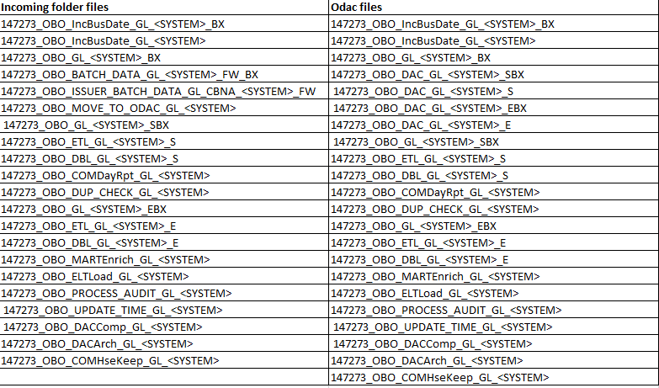

Job details View

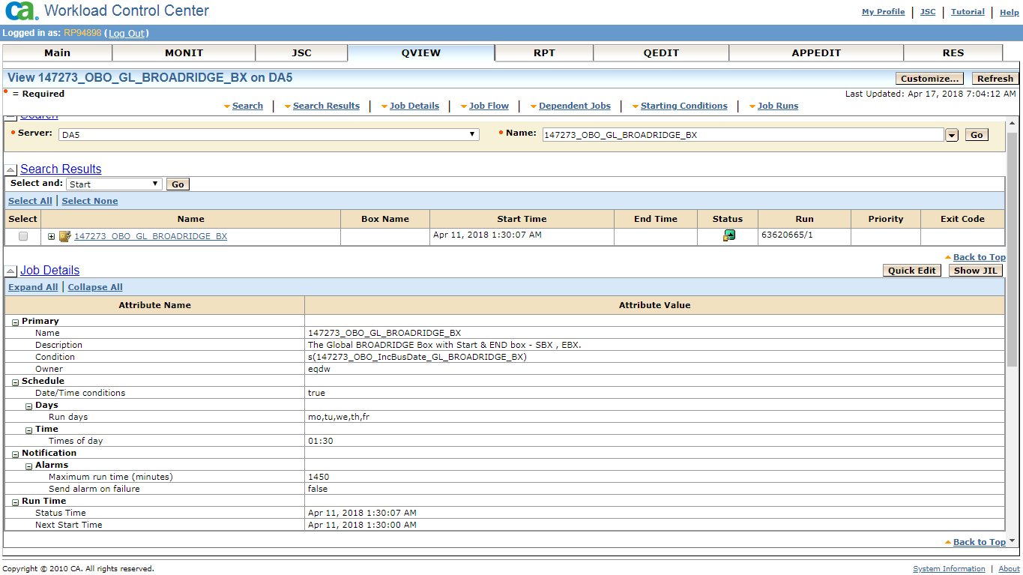

Job actions

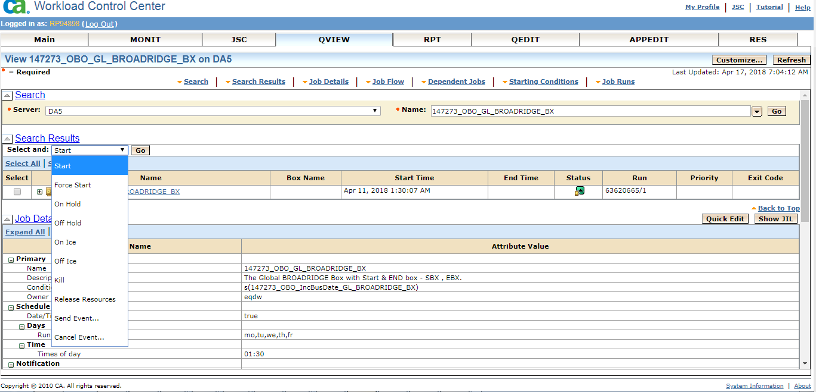

Viewing Log

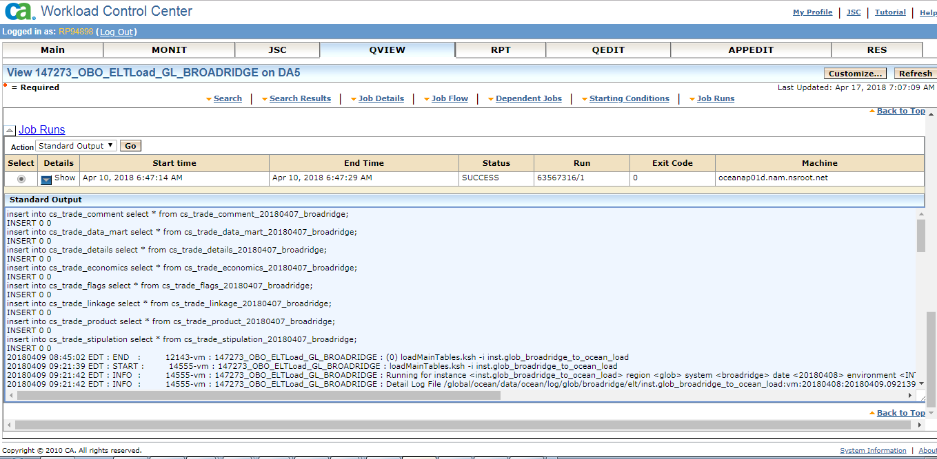

Editing Job

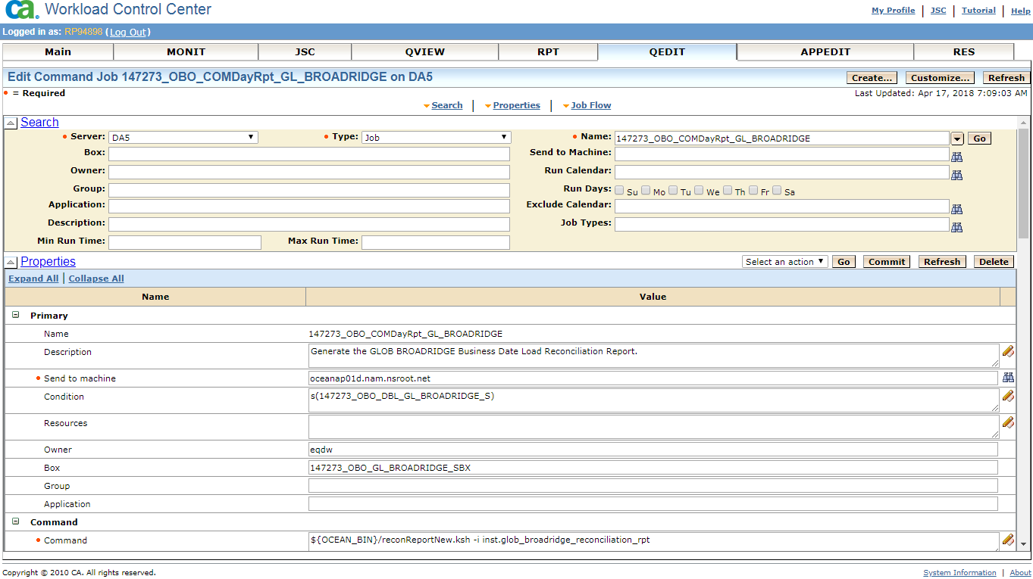

To create job

https://tidashap012mwp:8443/wcc/ui/Login.html

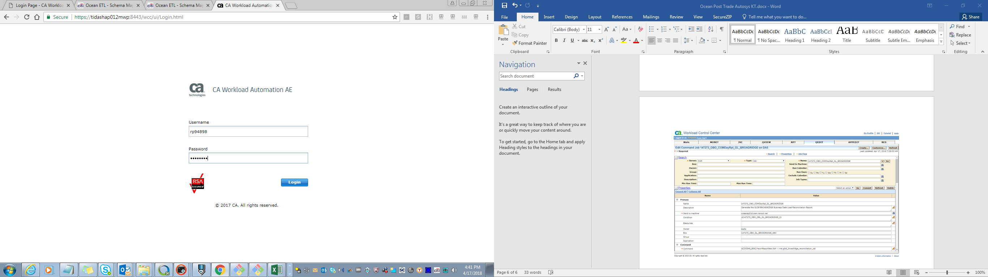

Navigate to Enterprise Command Line

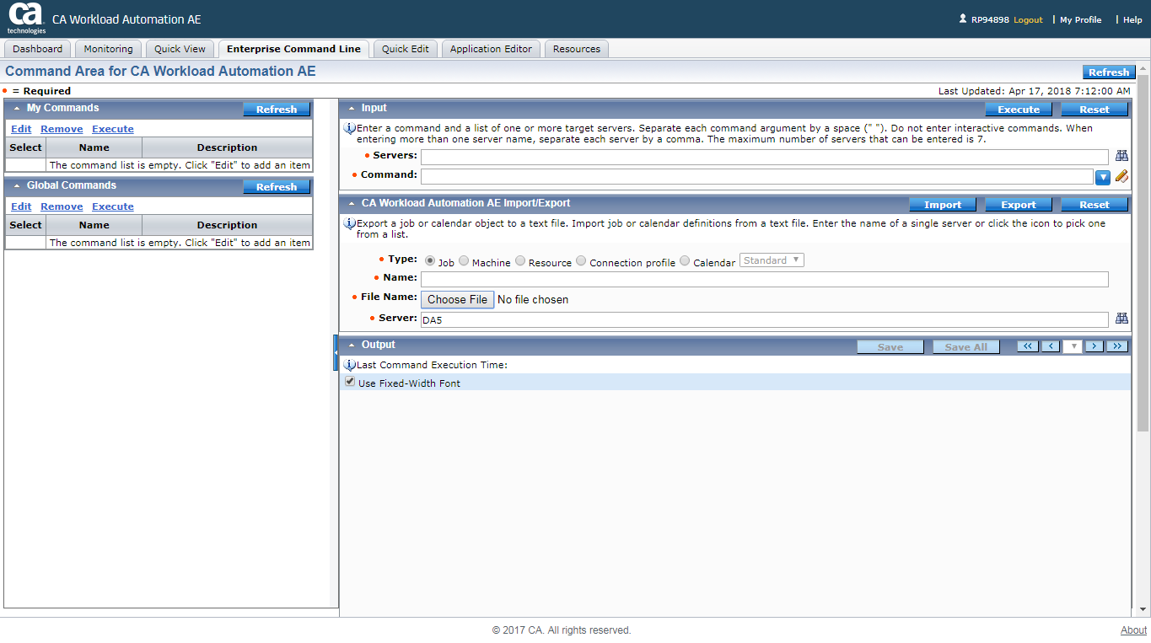

Edit

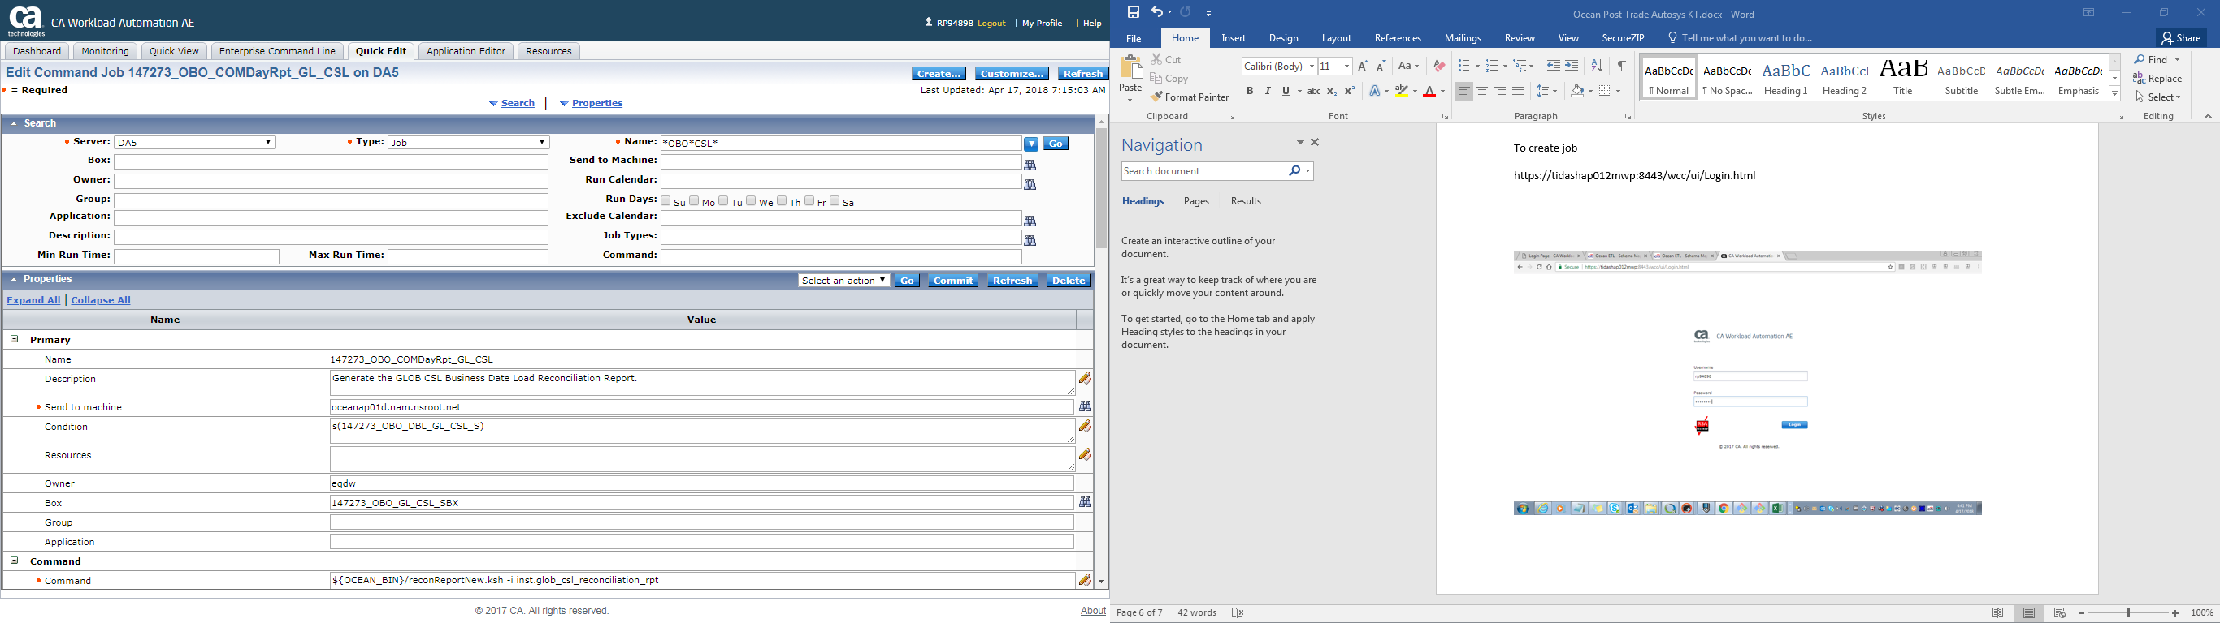

**Auto – generate scripts:**

Path : /home/mm75133/auto_scripts/obo_create_int_config.sh